STATE DEPARTMENT BOOSTS APICULTURE WITH BEEHIVE SUPPORT TO COMMUNITIES IN TURKANA AND KITUI

The State Department for Livestock Development has intensified efforts to strengthen apiculture across arid and semi-arid lands (ASALs) through the distribution of beehives to community groups in Turkana and Kitui counties, in a move aimed at enhancing livelihoods and building climate resilience.

Principal Secretary Jonathan Mueke participated in the distribution exercises that saw communities receive modern beehives to expand honey production and related value chains.
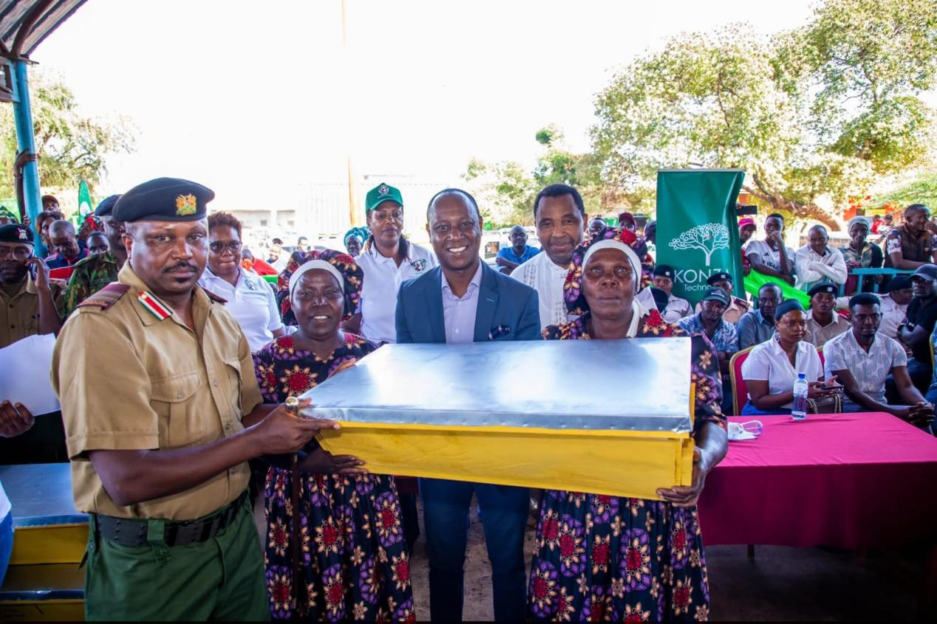
PS Mueke with a beneficiary women group from Nuu Ward (Kitui)

In Turkana County, bee farmers in Turkana Central and Loima sub-counties received 100 beehives to support the growth of apiculture in the region. The initiative is expected to help farmers diversify income sources while tapping into the county’s strong potential for honey production.

A similar intervention was carried out in Nuu Ward, Mwingi Central, Kitui County, where 100 beehives were delivered to women groups at Nuu Market. The support is designed to strengthen household incomes through honey production while encouraging community-driven agribusiness.
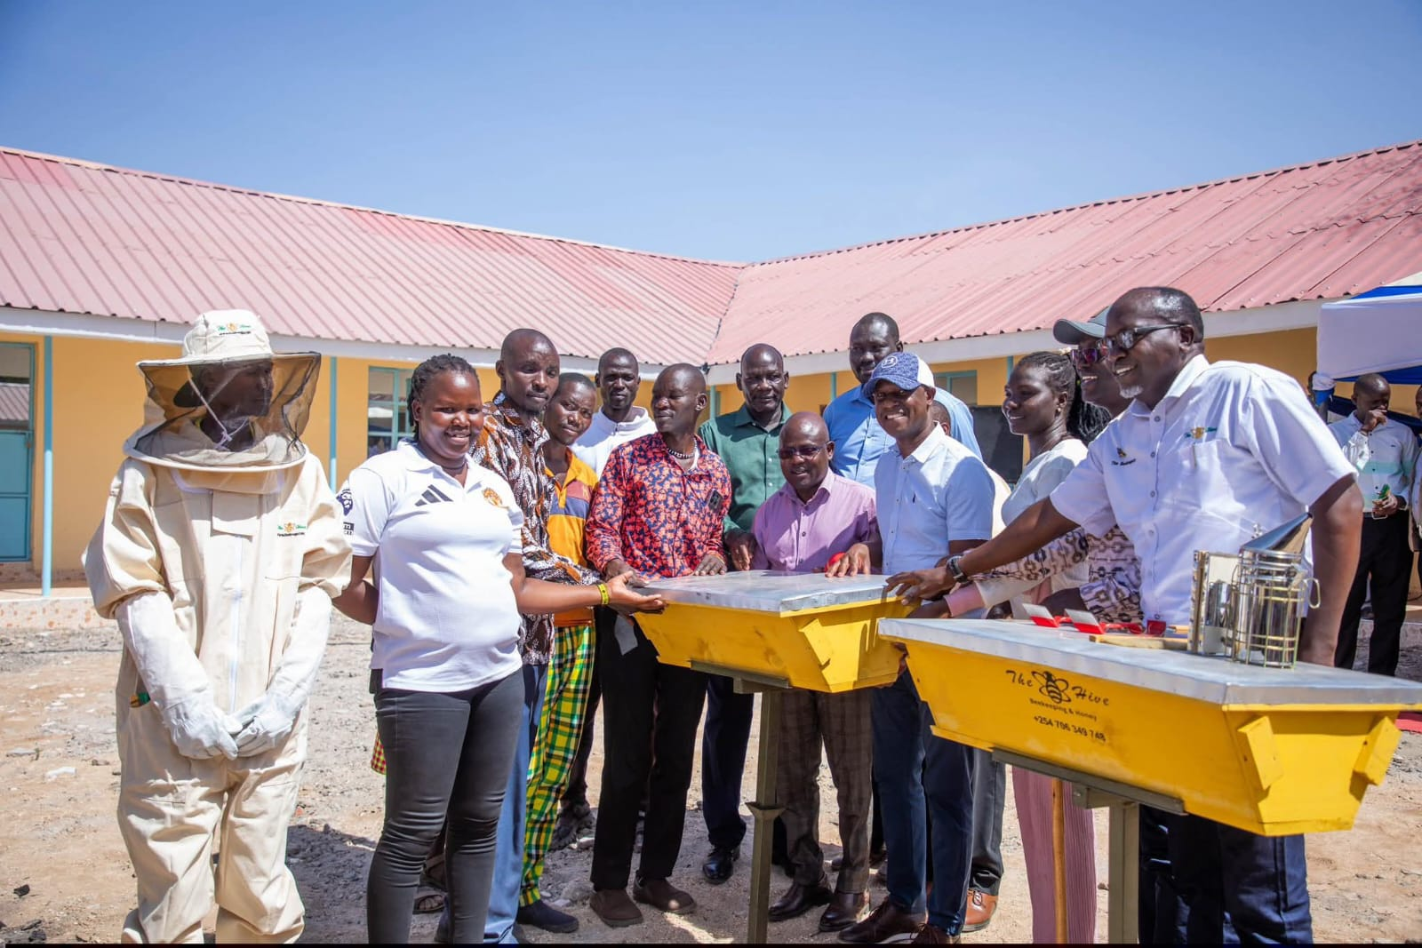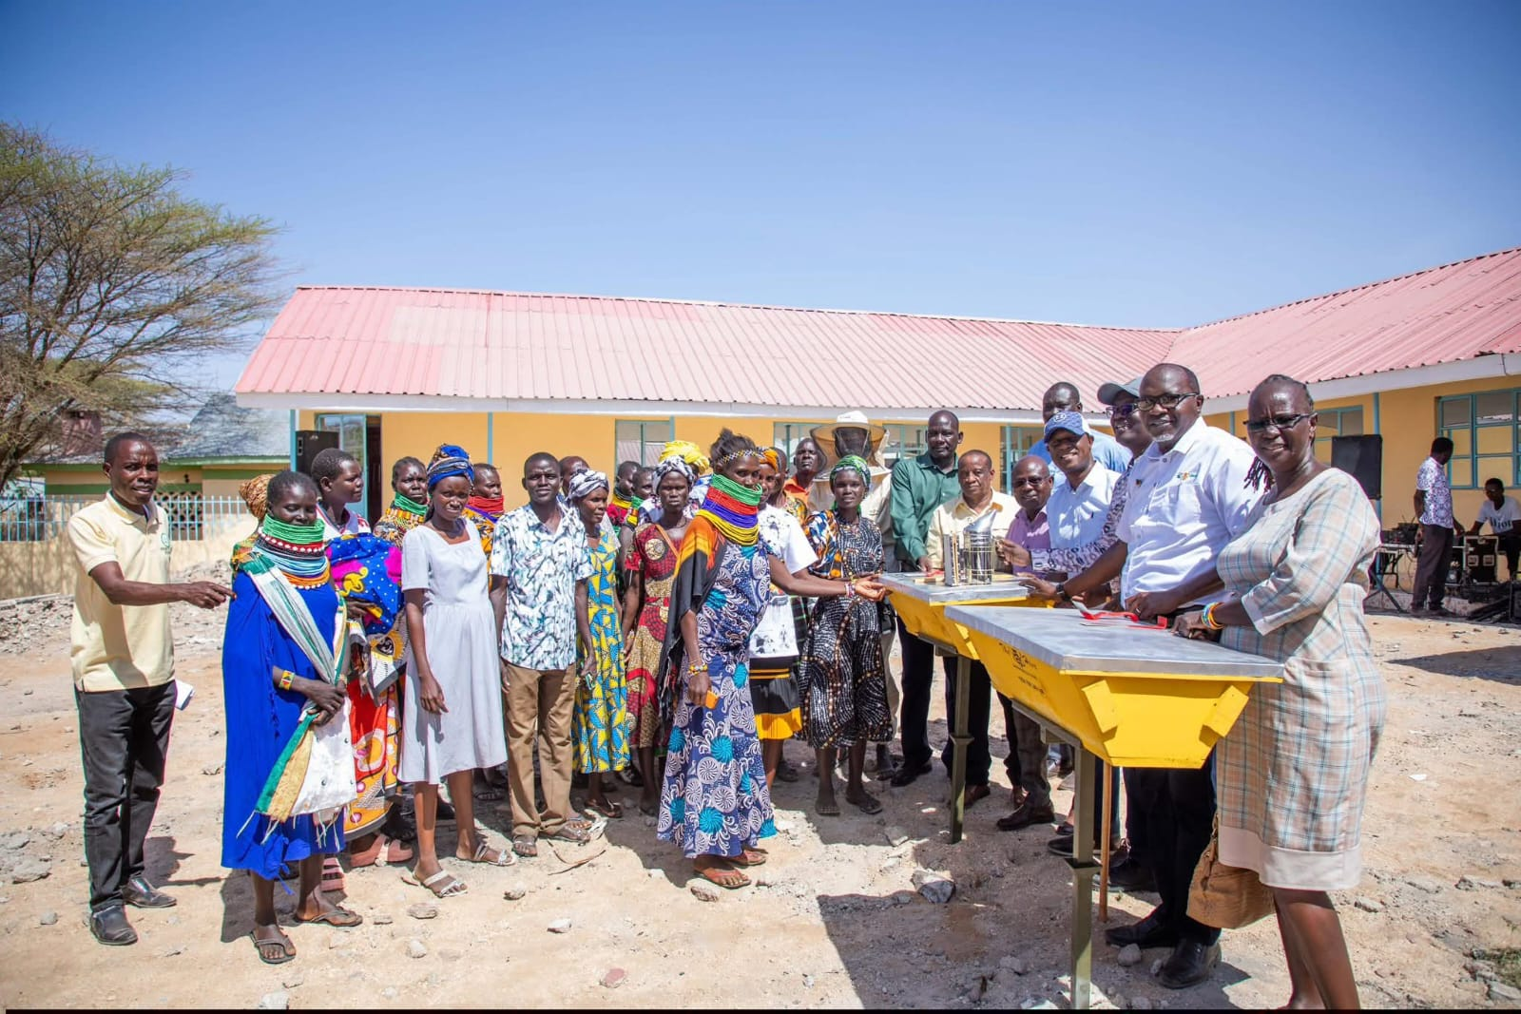
Beneficiary groups pose for photo with PS Mueke joined by political leaders (Turkana)

The beekeeping support programme targets community groups and smallholder farmers, particularly women, to enhance participation in income-generating activities along the bee and honey value chains. By expanding access to modern beehives, the initiative seeks to improve productivity while creating opportunities in honey harvesting, processing, and marketing.

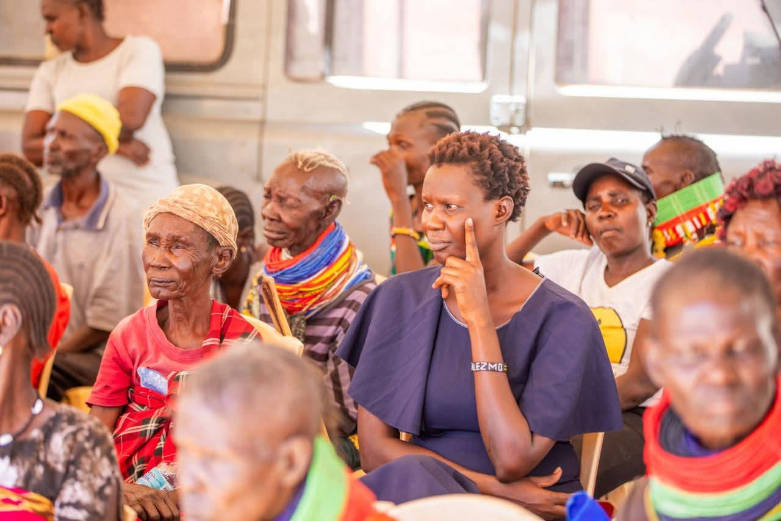
Beehives beneficiary Women groups from Kitui and Turkana Counties

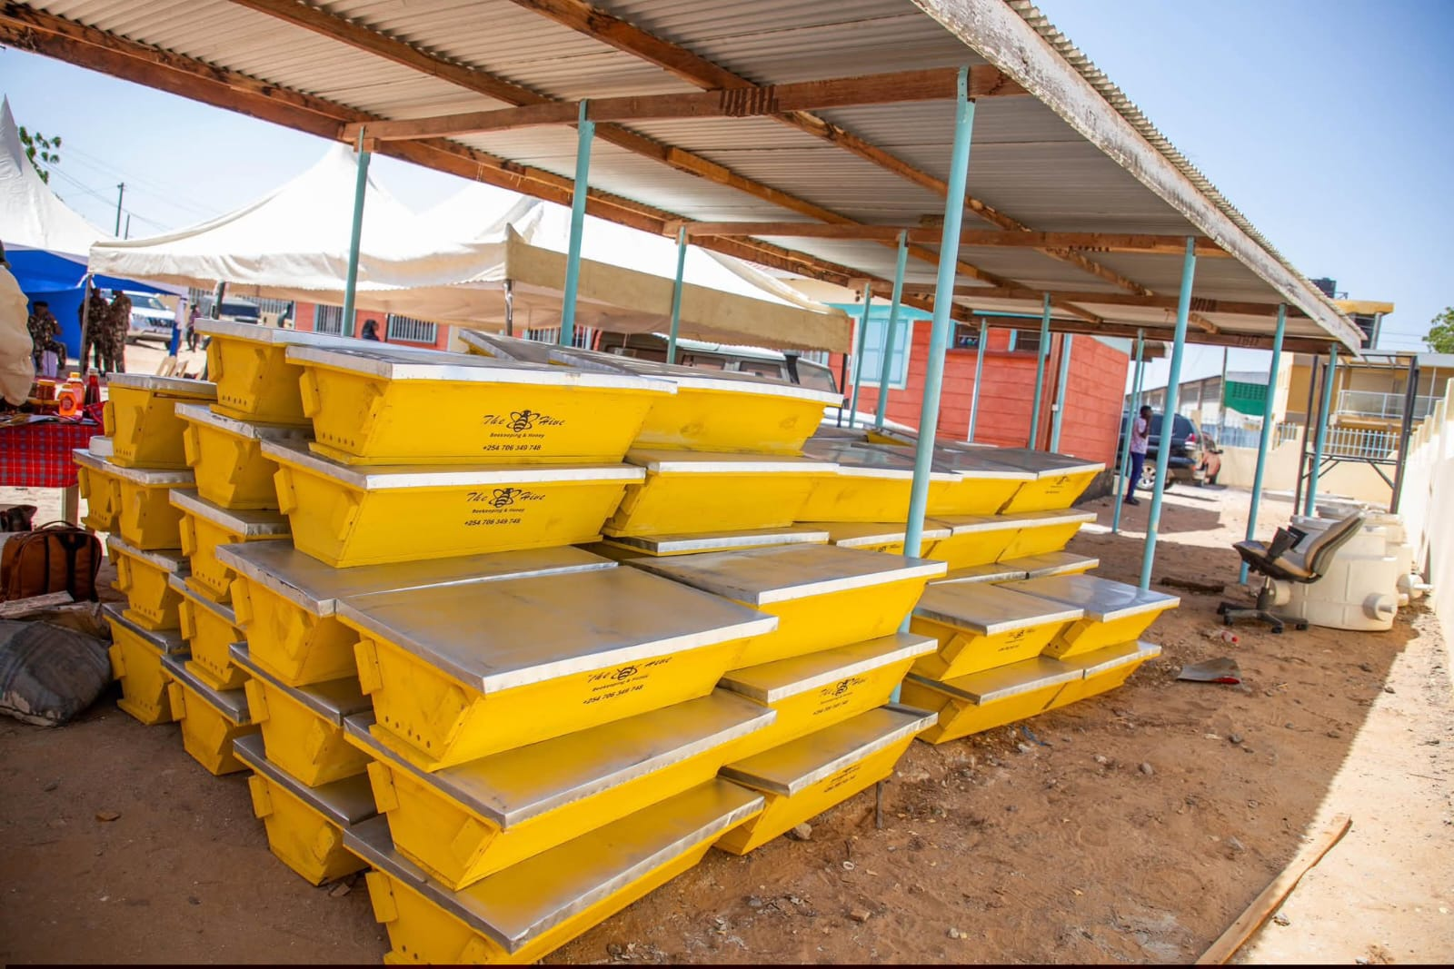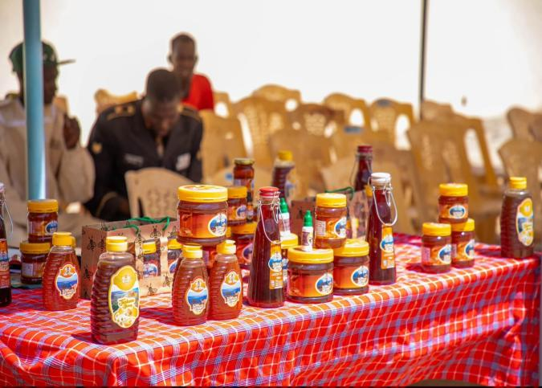
Kenya Top Bar Hives (KTBH) Honey products processed in Turkana

Apiculture continues to gain prominence as a climate-smart enterprise well suited for ASAL regions. Beekeeping requires minimal water and land, yet offers reliable economic returns while supporting environmental conservation through pollination.

Through such initiatives, the State Department for Livestock Development is promoting sustainable livestock-based enterprises that strengthen rural livelihoods, improve household resilience, and unlock economic opportunities within Kenya’s growing honey value chain.

