GOVERNMENT TRAINING COOPERATIVES ON THE QUALITY BASED MILK PAYMENT SYSTEM (QBMPS)
The State Department for Livestock Development has continued its nationwide push to shift the dairy sector from volume-based purchasing to a quality-based milk payment system. The System is designed to reward higher butterfat, protein content and compliance with hygiene and safety standards.
At a farmers’ training forum held in Meru, Hon. Jonathan Mueke, Principal Secretary in the State Department for Livestock Development explained that under QBMPS, farmers’ milk will be graded and paid according to measurable quality parameters rather than solely by litres delivered. He said the approach is intended to improve farm practices, raise incomes and make Kenya’s dairy products more competitive both locally and for export.

PS Mueke addressing Meru Dairy Cooperative members during a QBMPS training session
held in Meru County
The QBMPS model requires better feeding, herd management and adherence to hygiene standards, and will reward farmers who invest in improved breeds and good husbandry. Some processors are already paying premiums for high quality milk with reported farm-gate prices for premium milk exceeding KSh65 per litre in some areas.
Training and standards enforcement feature prominently in the roll-out. Meru Central Dairy Cooperative Union recently received ISO certification from the Kenya Bureau of Standards (KEBS), a development the State Department highlights as evidence that cooperatives can meet global quality benchmarks. The certification supports access to higher-value markets for dairy products such as yogurt, butter, ghee and cheese.

ISO Certificate handover to Meru Dairy Cooperative Union on completion of QBMPS training
Managing Director of the Kenya Dairy Board - Dr. William Maritim has underscored the need for strict movement control and disease prevention measures, warning that lapses in animal health or hygiene undermines the whole transition to a quality-driven system.
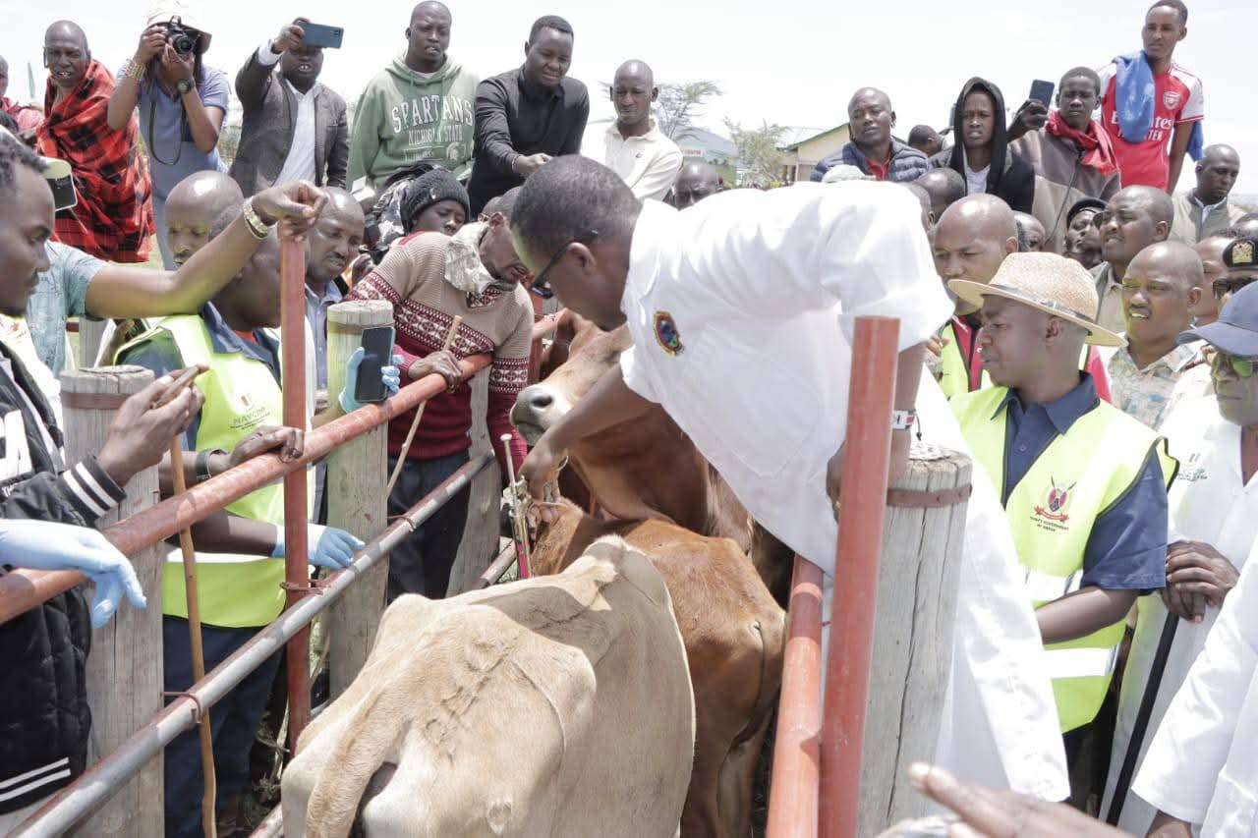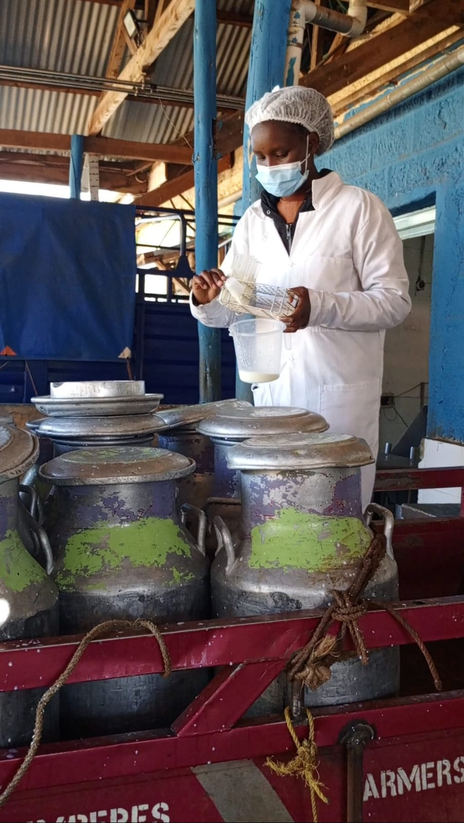
Mass Vaccination exercise towards the A lab technician collecting milk
eradication of FMD samples for quality testing
The QBMPS roll-out complements the government’s Bottom-Up Economic Transformation Agenda (BETA) by aiming to double milk production, contribute to human health, expand value addition, and grow exports.
Implementation will be phased and supported by processor partnerships, cooperatives capacity building and standards enforcement. The initial phases focus on training cooperative staff and farmers in balanced feeding, milk handling and basic milk-testing methods.
The State Department has invited cooperatives and processors to participate in the pilot phase and will publish technical guidelines on the QBMPS grading system and farmer-level requirements in the coming weeks.

