TREE-PLANTING DRIVE UNITES LIVESTOCK SECTOR STAKEHOLDERS AT NGONG HILLS
The State Department for Livestock Development (SDLD), in partnership with Zep-Re (PTA Reinsurance Company), led a major tree-planting exercise at Nalepo area in Ngong Hills, bringing together public institutions, development partners, and private sector actors in a shared commitment to environmental restoration.
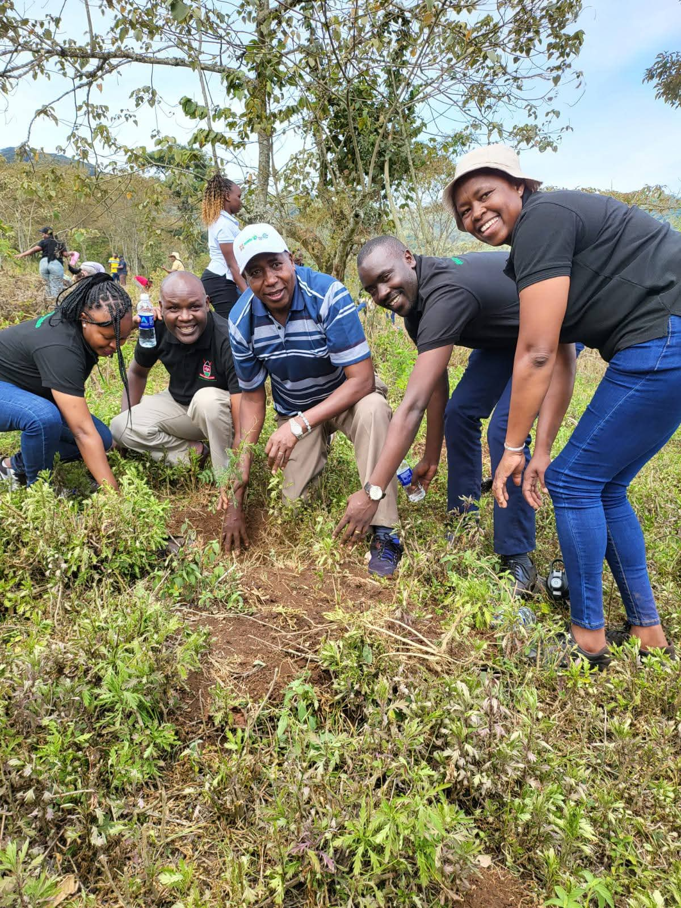
SDLD DA - Mr. Boniface Simba (middle) with a team from ZEP-RE
The initiative attracted strong participation from SDLD departments and its Semi-Autonomous Government Agencies (SAGAs), the DRIVE Project team, and several private companies. The collective effort demonstrated the power of collaboration in advancing sustainable environmental stewardship.
By the end of the exercise, participants had successfully planted 22,000 tree seedlings, primarily Acacia and Croton species, both well suited to Kenya’s rangelands and valued for their ecological and economic benefits.
The event was attended by senior leaders from across the livestock and environmental sectors. SDLD Director of Administration, Mr. Boniface Simba, represented Principal Secretary Jonathan Mueke. He was joined by Zep-Re CEO Madam Hope Murera, Dr. Mugo Principal - AHITI Kabete, Madam Karen Principal - National Beekeeping Institute and a team of dedicated SDLD officials who actively participated in the planting exercise.
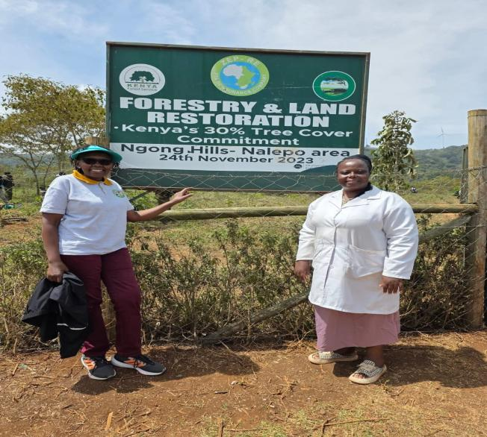 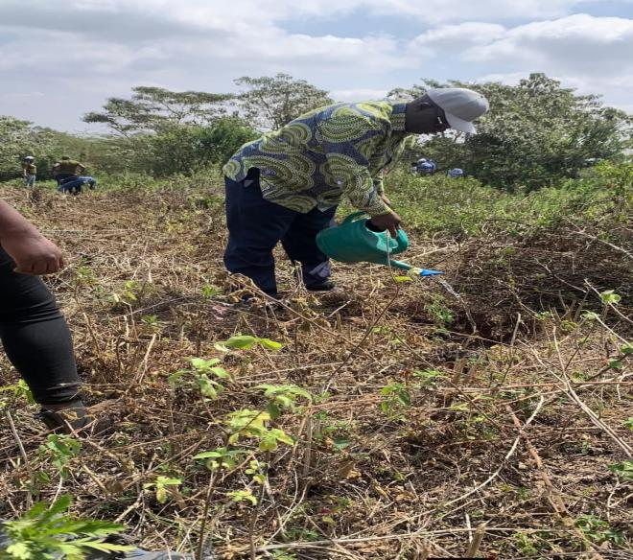 Madam Karen(left) - Principal, National Dr. Mugo - Principal, AHITI Kabete Beekeeping Institute with a staff member
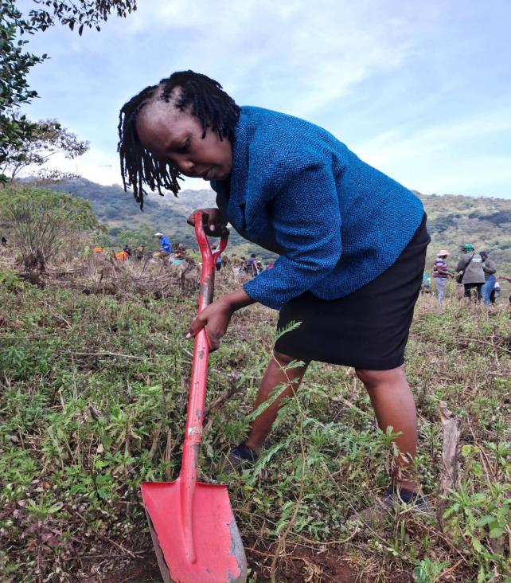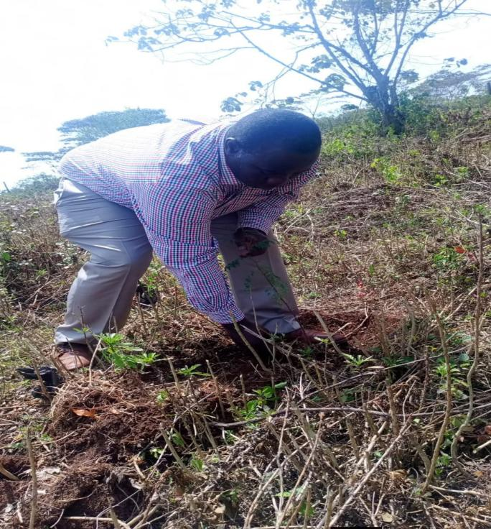
Madam Teresia - Deputy Principal, AHITI SDLD SDS - Jude Wesonga
Beyond the immediate act of planting trees, the exercise highlighted the broader role of trees in supporting livelihoods and ecosystems. Trees serve as nature’s infrastructure for improving air quality, enriching soils, protecting water sources, and providing shade and forage that support livestock production systems.
In pastoral and mixed farming landscapes, integrating trees into rangelands and farms contributes to healthier herds, improved biodiversity, and stronger resilience for rural communities facing increasing climate pressures.
The initiative aligns with Kenya’s national goal of growing 15 billion trees by 2032, a flagship commitment aimed at restoring degraded landscapes, strengthening climate resilience, and safeguarding natural resources for future generations.
Through partnerships such as this one, stakeholders in the livestock sector continue to demonstrate that environmental conservation and agricultural productivity can advance together, laying the foundation for a greener resilient Kenya.
The day in Pictures
